**ASSIGNMENT 1 (TECHSHOP)**

1. Create a database named “Techshop”;



1. Define the schema for the customer,products,order,orderDetails and inventory table. Based on the provided schema.

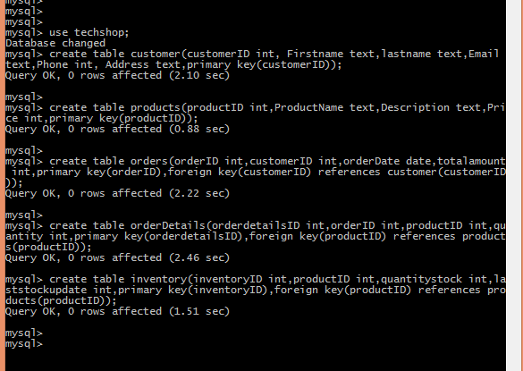

1. Insert at least 10 sample records into each of the following tables.
2. Customers
3. Products.
4. Orders
5. orderDetails.
6. Inventory

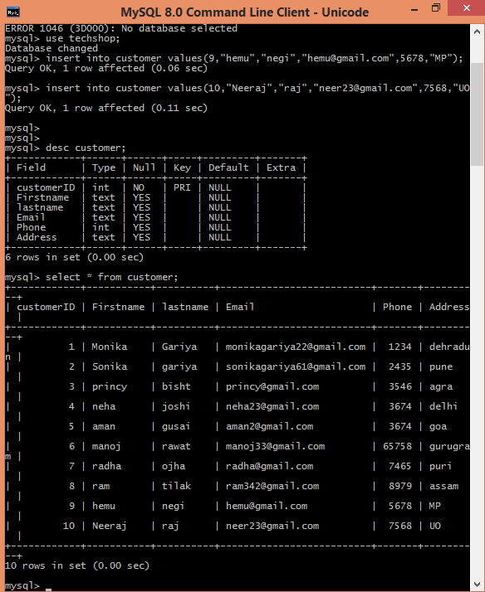

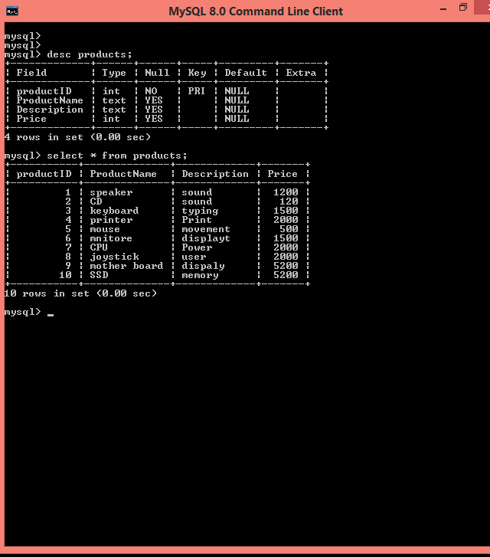

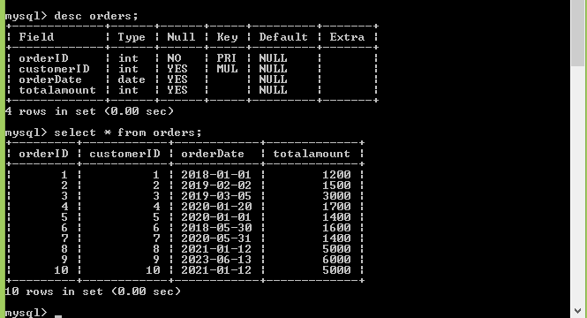

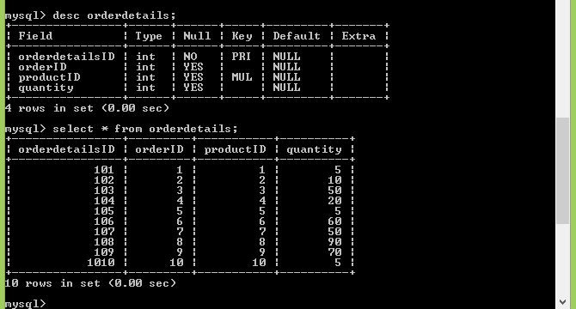

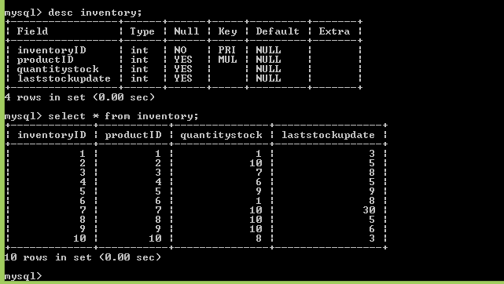

**TASK 2**

1) Write an SQL query to retrieve the names and emails of all customers.



2) Write an SQL query to list all orders with their order dates and corresponding customer names

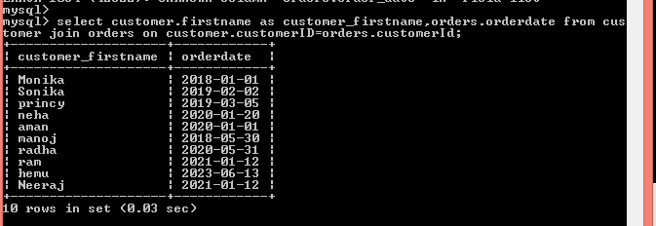

3) Write an SQL query to insert a new customer record into the "Customers" table. Include customer information such as name, email, and address.



4) Write an SQL query to update the prices of all electronic gadgets in the "Products" table by increasing them by 10%.

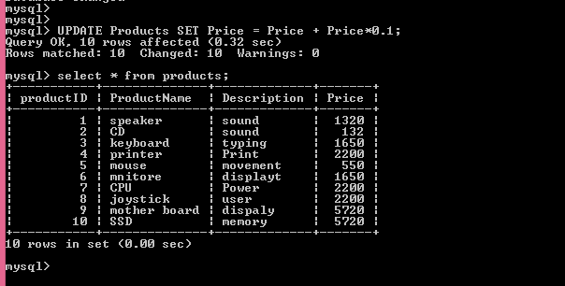

5) Write an SQL query to delete a specific order and its associated



6) Write an SQL query to insert a new order into the "Orders" table.

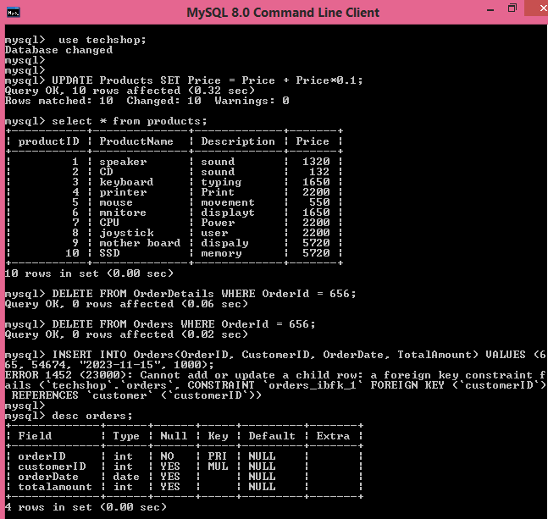

7) Write an SQL query to update the contact information (e.g., email and address) of a specific customer in the "Customers" table. Allow users to input the customer ID and new contact information.

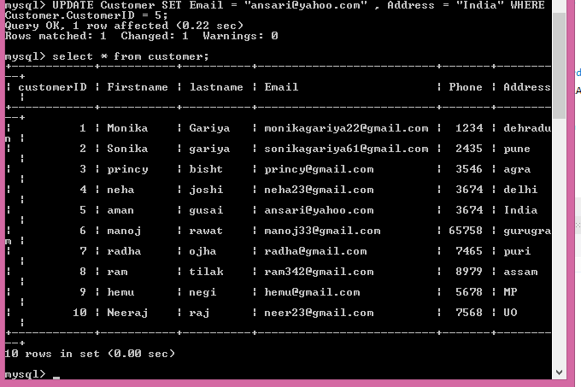

8) Write an SQL query to recalculate and update the total cost of each order in the "Orders" table based on the ordersproductsorderdetailsprices and quantities in the "OrderDetails" table

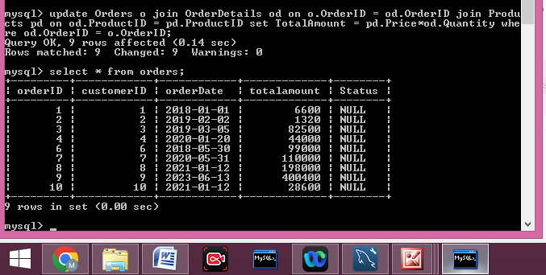

9 )Write an SQL query to delete all orders and their associated order details for a specific customer from the "Orders" and "OrderDetails" tables. Allow users to input the customer ID as a parameter

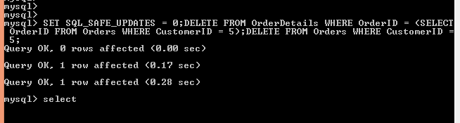

10) Write an SQL query to insert a new electronic gadget product into the "Products" table, including product name, category, price, and any other relevant details.

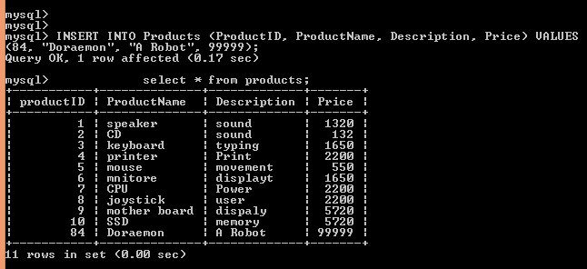

11 )Write an SQL query to update the status of a specific order in the "Orders" table (e.g., from "Pending" to "Shipped"). Allow users to input the order ID and the new status.



12 )Write an SQL query to calculate and update the number of orders placed by each customer customers in the "Customers" table based on the data in the "Orders" table.

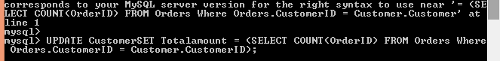

AGGREGATE FUNCTIONS,HAVING,ORDER BY,GROUP BY AND JOINS

1)Write an SQL query to retrieve a list of all orders along with customer information (e.g., customer name) for each order.Joins

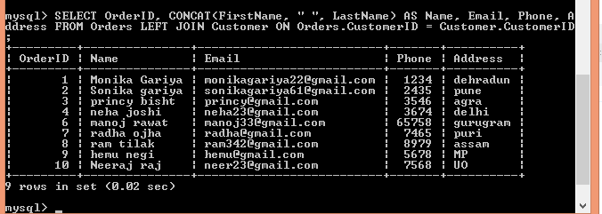

2) 2 Write an SQL query to find the total revenue generated by each electronic gadget product. Include the product name and the total revenue.

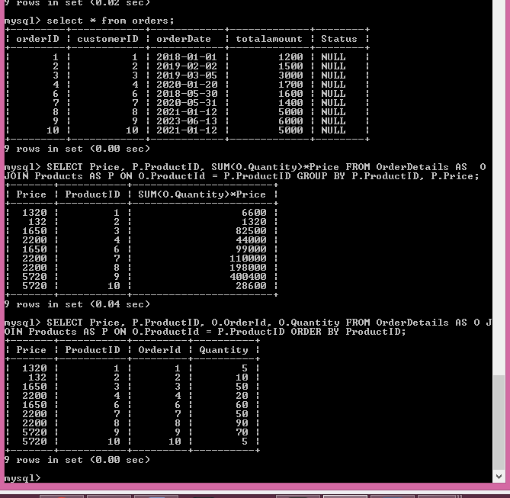

4 ) Write an SQL query to find the most popular electronic gadget, which is the one with the highest total quantity ordered. Include the product name and the total quantity ordered

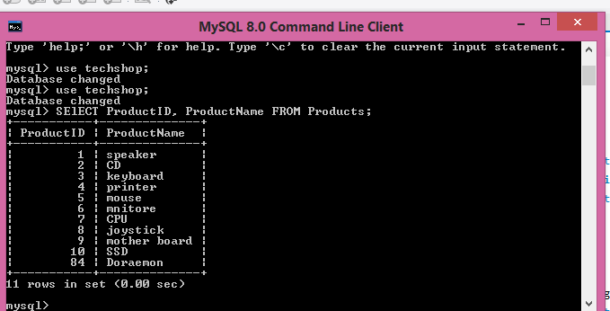

6 Write an SQL query to calculate the average order value for each customer. Include the customer's name and their average order value

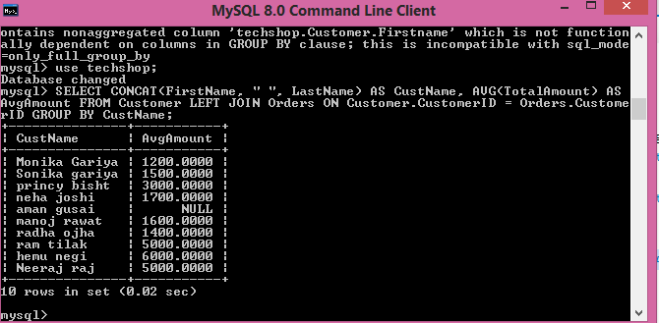

3.Write an SQL query to calculate the total revenue generated by TechShop.

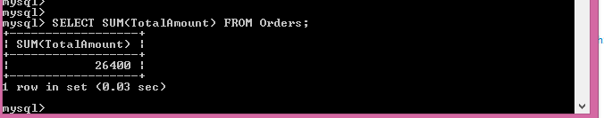

4. Write an SQL query to calculate the average quantity ordered for products in a specific category. Allow users to input the category name as a parameter